* **Faculty: Ho Hoan Kiem**
* **Team Member: Nguyễn Thành Đạt**

Review 1

## Project Information

* Project name: **CoffeeShop**
* Project Code: **CFS**
* Product Type: **Windows Forms Application**
* Start Date: **March 13th, 2020**
* End Date: **April 4th, 2020**

## 2. Current Situation

We plan to open a pub with large space to make our customers feel comfortable. In order to have a good management of a pub with a large space, the owner needs to hire a lot of employees to ensure the speed, accuracy and quality of the service.

## Problem Definition

Below are disadvantages of current situation:

* **Forget the table code**: With a large number of tables and a large number of guests, waiters may forget the code they are serving and cause customers to wait for extended periods of time. This will seriously affect the brand of the store in general and the shop owner in particular.
* **Hard to remember products**: employees have difficulty dividing products into categories with different prices
* **Many staffs**:With a large number of service personnel, the management is essential.
* **Waste time writing bills and statistics by hand:** When a customer comes to the store, and orders a lot. Employees must bill and charge guests with money. Sometimes employees write wrong, missing or redundant products. It will affect the total amount of money the customer has to pay and sometimes the employee must make up the deficit with their own pay.

## Proposed Solution

Our proposed solution is to build a management system called CFS System to deal with current situations.

The CFS system consists of a Windows Form Application.

### 4.1 Feature functions

* **Register account:** Create a new account. This function is only used by admin. They create a new account, if it not existed will be added and then give this account for staff.
* **View all, update, delete, reset password account:** update name, type of account or reset password when staff forgot.
* **Change profile account:** After receiving an account from an administrator, staffs can login and change the profile of this account for security and will be known only to staffs.
* **View all of foods, add / update / delete a food:** Admin can add food with information such as name, category, price, if this food is existed in system, system will show the message. When admin uses features like add / update / delete a food, the whole system will be updated immediately. If a table contains only this food, it will be updated to the status of empty tables.
* **View all, add / update / delete a category:** Admin can add category with information is name and show message if it is existed in system. When admin uses features like add / update / delete a category, the whole system will be updated immediately. When delete, the food of this category will also be deleted.
* **View all, add / update / delete / restore a table:** Admin can add table with information is name, status (empty or occupied) and show message if it is existed in system. When admin uses features like add / update / delete a category, the whole system will be updated immediately. Besides, admin can also restore the deleted table.
* **Bill statistics:** view bill that have been paid by the date.
* **Order product:** customers will talk to staff about the product they want and the staff will add that product to the bill at their table.
* **Switch table:** If the customer wants to change to another table. The staff will transfer their bill to that table in the system after which they can change.
* **Payment:** The payment will be based on the total amount of the invoice and the discount percentage charged to the customer.

### Advantages and disadvantages of Coffee Shop Application

* Advantages:
  + Save costs, time and increase accuracy, speed of service.
  + No need network.
  + Easily view and bill statistics at the end of the month.
  + Easy product management.
* Disadvantages:
  + It takes time for staff to get acquainted and use the software.
  + Sometimes the software will encounter some problems that I do not know in advance.

## Functional Requirements

Following is a list of functionalities of the application:

* **Admin component:**
  + Login application.
  + View bills by date.
  + Manage food.
  + Manage category.
  + Manage table.
  + Manage account.
  + More food.
  + Switch table.
  + Payment.
  + Logout application.
* **Staff component:** 
  + Login application. (account provided by administrator)
  + More food.
  + Switch table.
  + Payment.
  + Edit profile.
  + Logout application

1. Technology and technique

The application is built in 3-layers architecture, using Singleton Pattern technique.

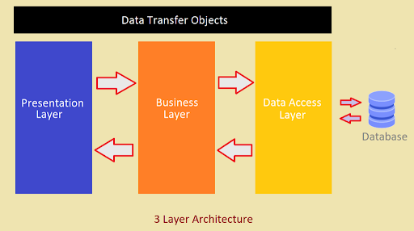

Review 2

Use Case Diagram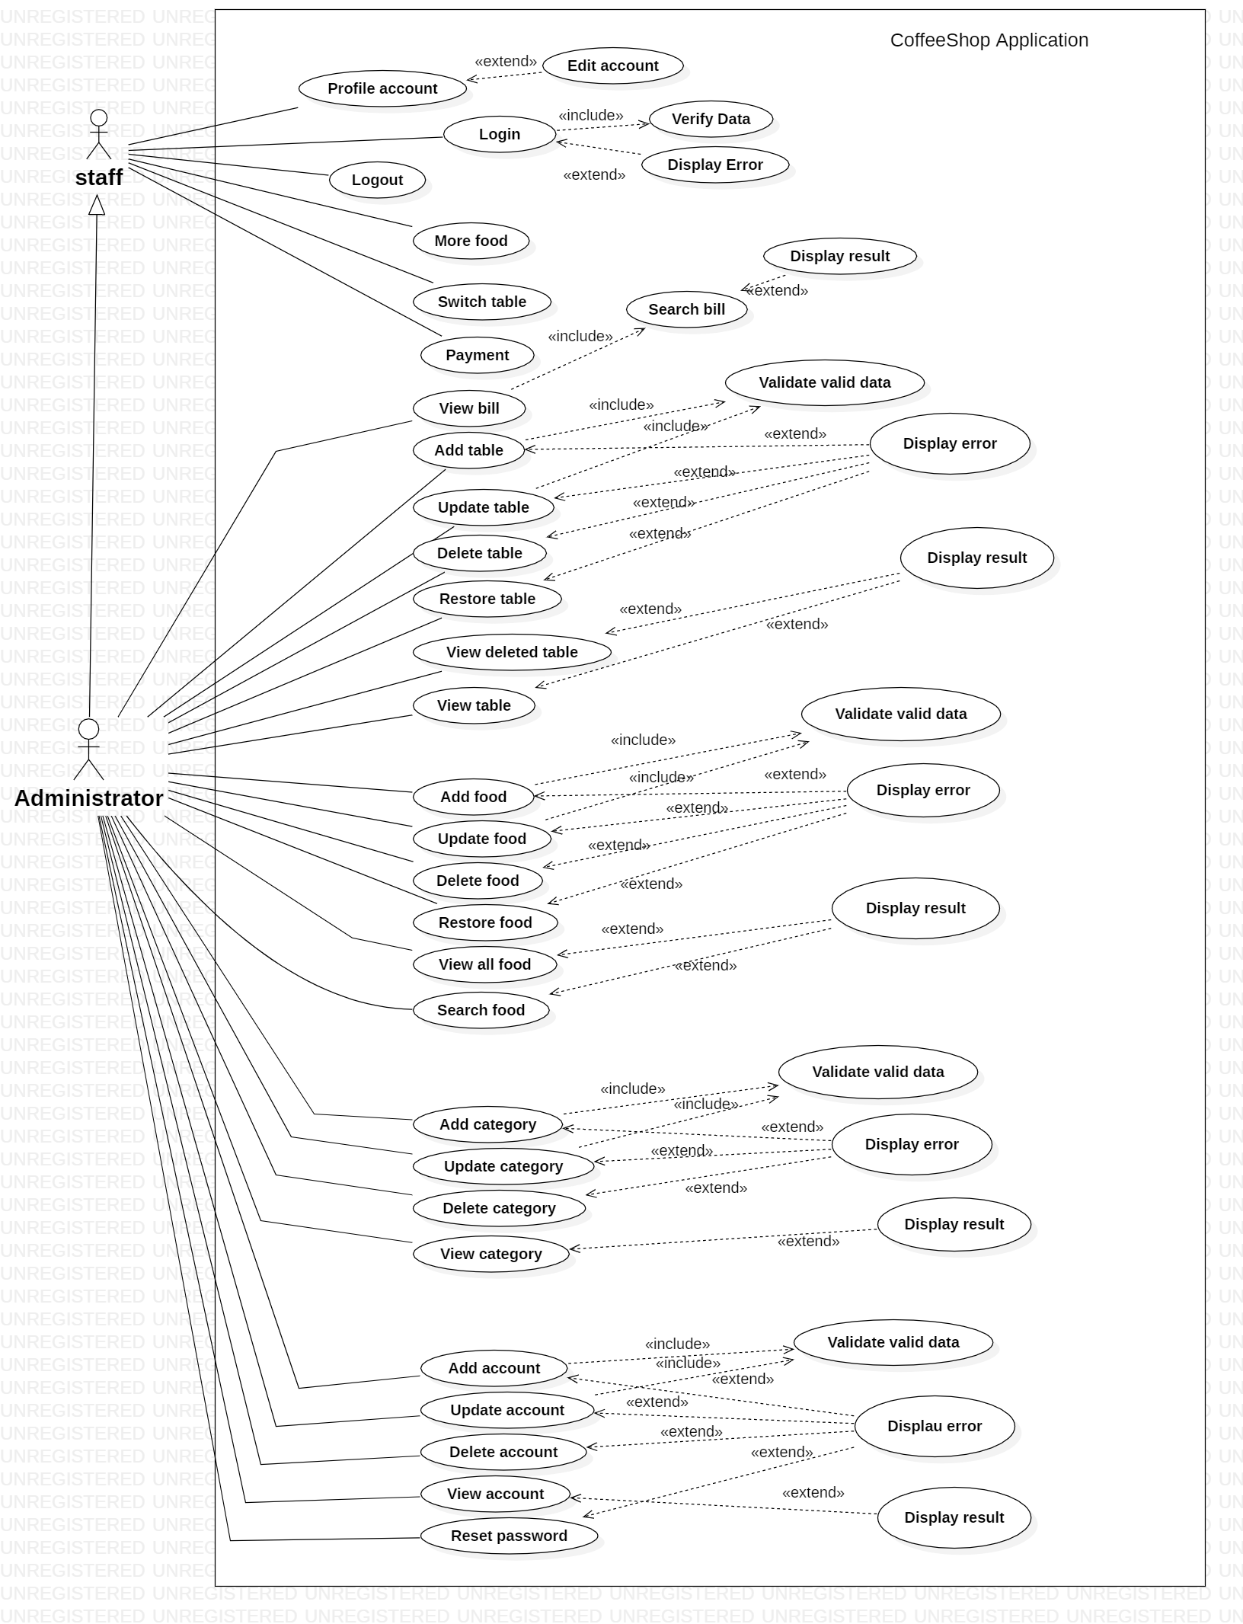

Use Case DESCRIPTION

1. **Actor:**

* **staff :** staff is employee in the pub can use some basic function of applicattion.
* **Administrator :** can use all function of application.

1. **Usecase:**

|  |  |
| --- | --- |
| **Usecase** | Login |
| **Short Description** | Login to app to use function of staff or administrator. |
| **Pre-Conditions** |  |
| **Post-Conditions** |  |
| **Main flow** | _Input:   * Username. * Password.   _Click on the Login button. _System check the Username and Password _If Username ang Password is valid with Type “staff”, system will show the form manager and only use function for staff. _If Username ang Password is valid with Type “admin”, system will show the form manager and can use all function of application. _If Username or Password is wrong a message will show up and tell the user “Invalid username or password” |
| **Alternative flow(s)** | _If the Username or Password field is blank, system will show a message “Invalid username or password”. |

|  |  |
| --- | --- |
| **Usecase** | Edit Account |
| **Short Description** | After login successfully, user can edit account information. |
| **Pre-Conditions** | Login successfully. |
| **Post-Conditions** | The system will display a message “Update Account Successfully!” |
| **Main flow** | _User will enter information to edit and click save button. _System will check information and save it to database. _System notify to user. |
| **Alternative flow(s)** | _If any information are invalid, system will notify the error. |

|  |  |
| --- | --- |
| **Usecase** | More Food |
| **Short Description** | Add product to bill of customer. |
| **Pre-Conditions** |  |
| **Post-Conditions** |  |
| **Main flow** | _User must login. _User click table of customer and choose the product they want in system . _Click More food button to add into their bill. |
| **Alternative flow(s)** | _If can’t find the table, system will notify error. |

|  |  |
| --- | --- |
| **Usecase** | Switch Table |
| **Short Description** | Swap 2 tables and bill together. |
| **Pre-Conditions** |  |
| **Post-Conditions** |  |
| **Main flow** | _User must login. _Click table and select table want to convert in combobox. _Click Switch table button to convert. |
| **Alternative flow(s)** | _If can’t find the table, system will notify error. |

|  |  |
| --- | --- |
| **Usecase** | Payment |
| **Short Description** | Pay the bill to the customer. |
| **Pre-Conditions** |  |
| **Post-Conditions** |  |
| **Main flow** | _User must login. _Click table with status “occupied” and Click Payment button to pay thi bill. _System display notify “OK” or “Cancel”. |
| **Alternative flow(s)** | _If can’t find the table, system will notify error. _If table does not have a bill, this function can’t active. |

|  |  |
| --- | --- |
| **Usecase** | View Bill |
| **Short Description** | Admin view bills by date check in and check out |
| **Pre-Conditions** |  |
| **Post-Conditions** |  |
| **Main flow** | _Admin login to app _Click admin in menuStrip _Select date check in and date check out _Click View bill to see details of bill. |
| **Alternative flow(s)** |  |

|  |  |
| --- | --- |
| **Usecase** | Add Table |
| **Short Description** | Add a new table to system. |
| **Pre-Conditions** |  |
| **Post-Conditions** |  |
| **Main flow** | _Admin login to app _Click admin in menuStrip and choose tag table.  _Full fill information need to create and click the Add button. _System will check information and save it to database. _System display notify. _Reload table list. |
| **Alternative flow(s)** | _If any information are invalid or an error occurred, system will notify the error. |

|  |  |
| --- | --- |
| **Usecase** | Update Table |
| **Short Description** | Update table information in system. |
| **Pre-Conditions** |  |
| **Post-Conditions** |  |
| **Main flow** | _Admin login to app _Click admin in menuStrip and choose tag table.  _Click table in list want to update _Full fill information need to update and click the Update button. _System will check information and save it to database. _System display notify. _Reload table list. |
| **Alternative flow(s)** | _If any information are invalid or an error occurred, system will notify the error. |

|  |  |
| --- | --- |
| **Usecase** | Delete Table |
| **Short Description** | Detele table. |
| **Pre-Conditions** |  |
| **Post-Conditions** |  |
| **Main flow** | _Admin login to app _Click admin in menuStrip and choose tag table.  _Click table in list want to delete. _Click the Delete button. _System display notify. _Reload table list. |
| **Alternative flow(s)** | _If an error occurred, system will notify the error. |

|  |  |
| --- | --- |
| **Usecase** | Restore Table |
| **Short Description** | Restore table when deleted |
| **Pre-Conditions** |  |
| **Post-Conditions** |  |
| **Main flow** | _Admin login to app _Click admin in menuStrip and choose tag table.  _Click table in list want to restore. _Click the Restore button. _System display notify. _Reload table list. |
| **Alternative flow(s)** | _If an error occurred, system will notify the error. |

|  |  |
| --- | --- |
| **Usecase** | View Deleted Table |
| **Short Description** | View detail of table in table list deleted |
| **Pre-Conditions** |  |
| **Post-Conditions** |  |
| **Main flow** | _Admin login to app _Click admin in menuStrip and choose tag table.  _Click the View Deleted button. _System display a list detail of table deleted. |
| **Alternative flow(s)** |  |

|  |  |
| --- | --- |
| **Usecase** | View Table |
| **Short Description** | View detail of table |
| **Pre-Conditions** |  |
| **Post-Conditions** |  |
| **Main flow** | _Admin login to app _Click admin in menuStrip and choose tag table.  _Click the View button. _System display a list detail of table. |
| **Alternative flow(s)** |  |

|  |  |
| --- | --- |
| **Usecase** | Add Food |
| **Short Description** | Add a new food to system |
| **Pre-Conditions** |  |
| **Post-Conditions** |  |
| **Main flow** | _Admin login to app _Click admin in menuStrip and choose tag food.  _Full fill information need to create and click the Add button. _System will check information and save it to database. _System show norify. _Reload food list. |
| **Alternative flow(s)** | _If any information are invalid or an error occurred, system will notify the error. |

|  |  |
| --- | --- |
| **Usecase** | Update Food |
| **Short Description** | Update food information in system |
| **Pre-Conditions** |  |
| **Post-Conditions** |  |
| **Main flow** | _Admin login to app _Click admin in menuStrip and choose tag food.  _Click food in list want to update _Full fill information need to update and click the Update button. _System will check information and save it to database. _System display notify. _Reload food list. |
| **Alternative flow(s)** | _If any information are invalid or an error occurred, system will notify the error. |

|  |  |
| --- | --- |
| **Usecase** | Delete Food |
| **Short Description** | Delete a food |
| **Pre-Conditions** |  |
| **Post-Conditions** |  |
| **Main flow** | _Admin login to app _Click admin in menuStrip and choose tag food.  _Click food in list want to delete. _Click the Delete button. _System display notify. _Reload food list. |
| **Alternative flow(s)** | _If an error occurred, system will notify the error. |

|  |  |
| --- | --- |
| **Usecase** | Restore Food |
| **Short Description** | Restore a food when deleted |
| **Pre-Conditions** |  |
| **Post-Conditions** |  |
| **Main flow** | _Admin login to app _Click admin in menuStrip and choose tag food.  _Click radio button inactive. _Click food in list want to restore. _Click the Restore button. _System display notify. _Reload food list. |
| **Alternative flow(s)** | _If an error occurred, system will notify the error. |

|  |  |
| --- | --- |
| **Usecase** | View All Food |
| **Short Description** | View detail of food |
| **Pre-Conditions** |  |
| **Post-Conditions** |  |
| **Main flow** | _Admin login to app _Click admin in menuStrip and choose tag food.  _Click the View button. _System display a list detail of food. |
| **Alternative flow(s)** |  |

|  |  |
| --- | --- |
| **Usecase** | Search Food |
| **Short Description** | Find a food in list |
| **Pre-Conditions** |  |
| **Post-Conditions** |  |
| **Main flow** | _Admin login to app _Click admin in menuStrip and choose tag food.  _Fill in search food text filed. _Click Search button. _System display a list detail of food with search value. |
| **Alternative flow(s)** |  |

|  |  |
| --- | --- |
| **Usecase** | Add Category |
| **Short Description** | Add a new category to system |
| **Pre-Conditions** |  |
| **Post-Conditions** |  |
| **Main flow** | _Admin login to app _Click admin in menuStrip and choose tag category.  _Full fill information need to create and click the Add button. _System will check information and save it to database. _System display notify. _Reload category list. |
| **Alternative flow(s)** | _If any information are invalid or an error occurred, system will notify the error. |

|  |  |
| --- | --- |
| **Usecase** | Update Category |
| **Short Description** | Update information of category in system |
| **Pre-Conditions** |  |
| **Post-Conditions** |  |
| **Main flow** | _Admin login to app _Click admin in menuStrip and choose tag category.  _Full fill information need to update and click the Update button. _System will check information and save it to database. _System display notify. _Reload category list. |
| **Alternative flow(s)** | _If any information are invalid or an error occurred, system will notify the error. |

|  |  |
| --- | --- |
| **Usecase** | Delete Category |
| **Short Description** | Delete category in list |
| **Pre-Conditions** |  |
| **Post-Conditions** |  |
| **Main flow** | _Admin login to app _Click admin in menuStrip and choose tag category.  _Click category in list want to delete. _Click the Delete button. _System display notify. _Reload category list. |
| **Alternative flow(s)** | _If an error occurred, system will notify the error. |

|  |  |
| --- | --- |
| **Usecase** | View Category |
| **Short Description** | View detail of category. |
| **Pre-Conditions** |  |
| **Post-Conditions** |  |
| **Main flow** | _Admin login to app _Click admin in menuStrip and choose tag category.  _Click the View button. _System display a list detail of category. |
| **Alternative flow(s)** |  |

|  |  |
| --- | --- |
| **Usecase** | Add Account |
| **Short Description** | Add a new account to system |
| **Pre-Conditions** |  |
| **Post-Conditions** |  |
| **Main flow** | _Admin login to app _Click admin in menuStrip and choose tag account.  _Click New button and choose ADD button. _Full fill information need to create with default type is “staff” and click the Add button. _System will check information and save it to database. _System display notify. _Reload account list. |
| **Alternative flow(s)** | _If any information are invalid or an error occurred, system will notify the error. |

|  |  |
| --- | --- |
| **Usecase** | Update Account |
| **Short Description** | Update account information in system |
| **Pre-Conditions** |  |
| **Post-Conditions** |  |
| **Main flow** | _Admin login to app _Click admin in menuStrip and choose tag account.  _Click New button and choose UPDATE button. _Full fill information need to update and click the Update button. _System will check information and save it to database. _System display notify. _Reload account list. |
| **Alternative flow(s)** | _If any information are invalid or an error occurred, system will notify the error. |

|  |  |
| --- | --- |
| **Usecase** | Delete Account |
| **Short Description** | Delete account |
| **Pre-Conditions** |  |
| **Post-Conditions** |  |
| **Main flow** | _Admin login to app _Click admin in menuStrip and choose tag account.  _Click account in list want to delete. _Click the Delete button. _System display notify. _Reload account list. |
| **Alternative flow(s)** | _If an error occurred, system will notify the error. |

|  |  |
| --- | --- |
| **Usecase** | View Account |
| **Short Description** | View detail |
| **Pre-Conditions** |  |
| **Post-Conditions** |  |
| **Main flow** | _Admin login to app _Click admin in menuStrip and choose tag account.  _Click the View button. _System display a list detail of account. |
| **Alternative flow(s)** |  |

|  |  |
| --- | --- |
| **Usecase** | Reset Password |
| **Short Description** | Reset account to default password |
| **Pre-Conditions** |  |
| **Post-Conditions** |  |
| **Main flow** | _Admin login to app _Click admin in menuStrip and choose tag account.  _Click account in list want to reset. _Click the Reset Password button. _System display notify. |
| **Alternative flow(s)** |  |

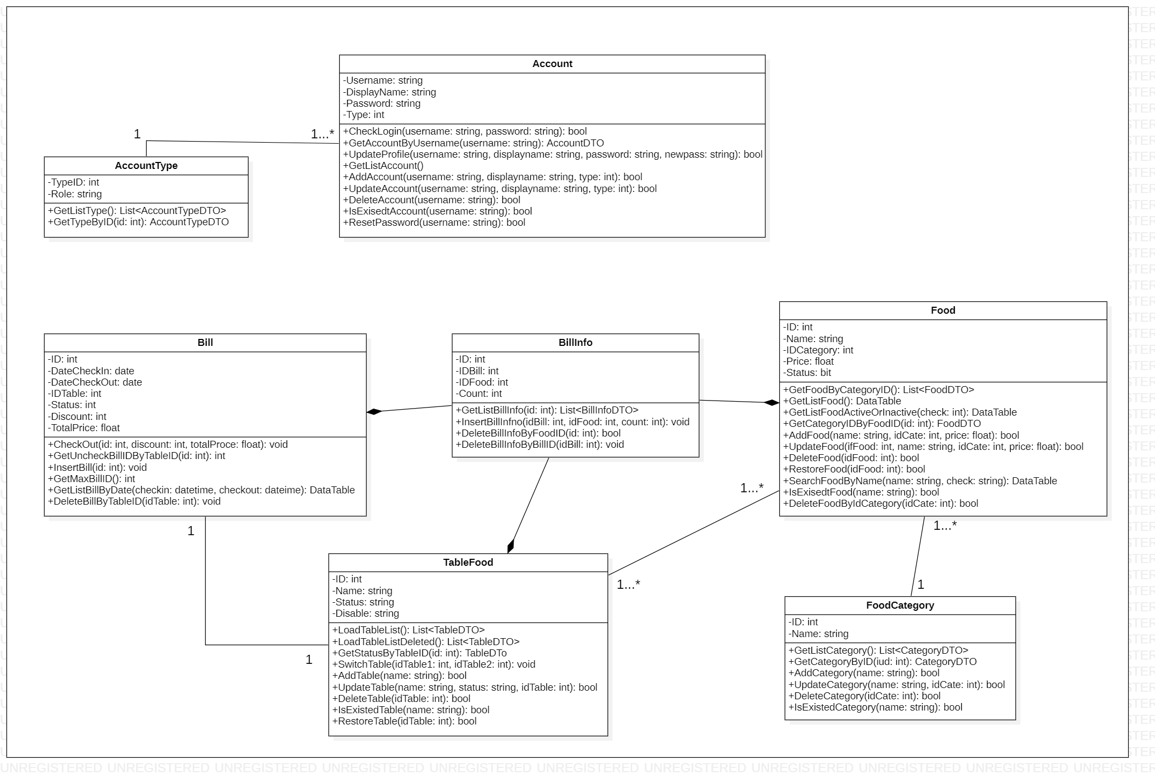Class Diagram

Sequence Diagramn

1. Login.

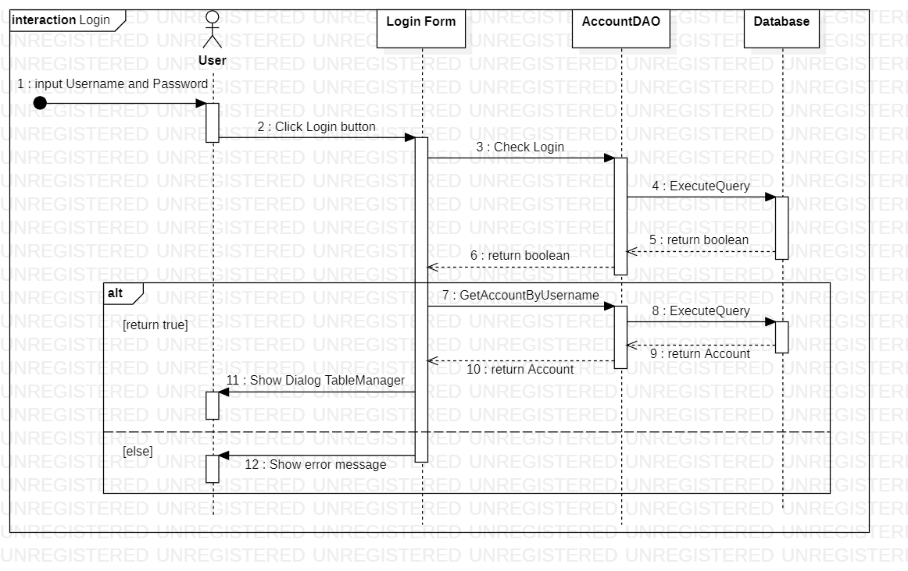

1. 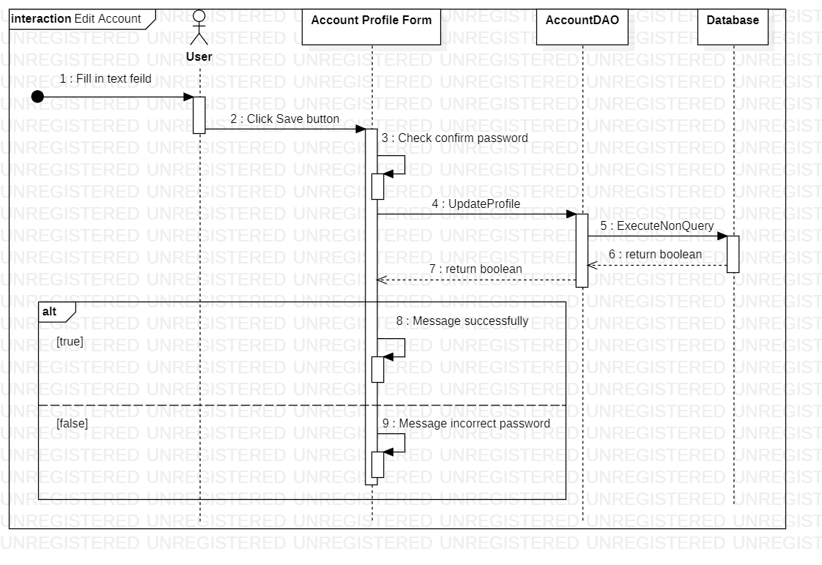Edit Account.
2. 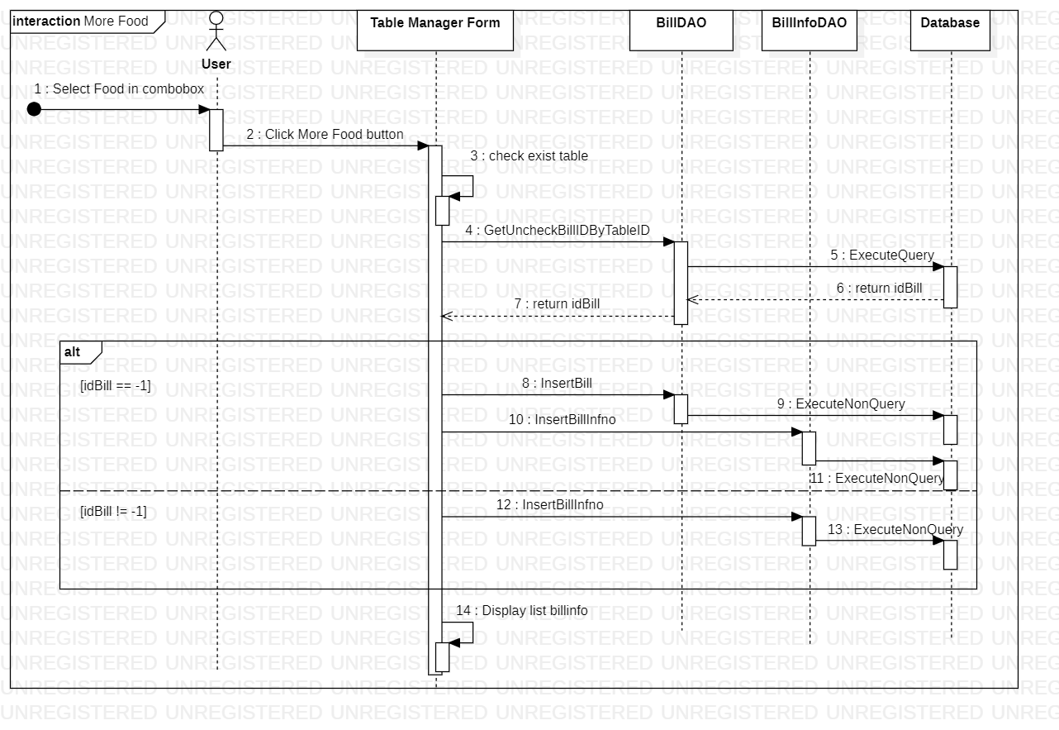More Food.
3. 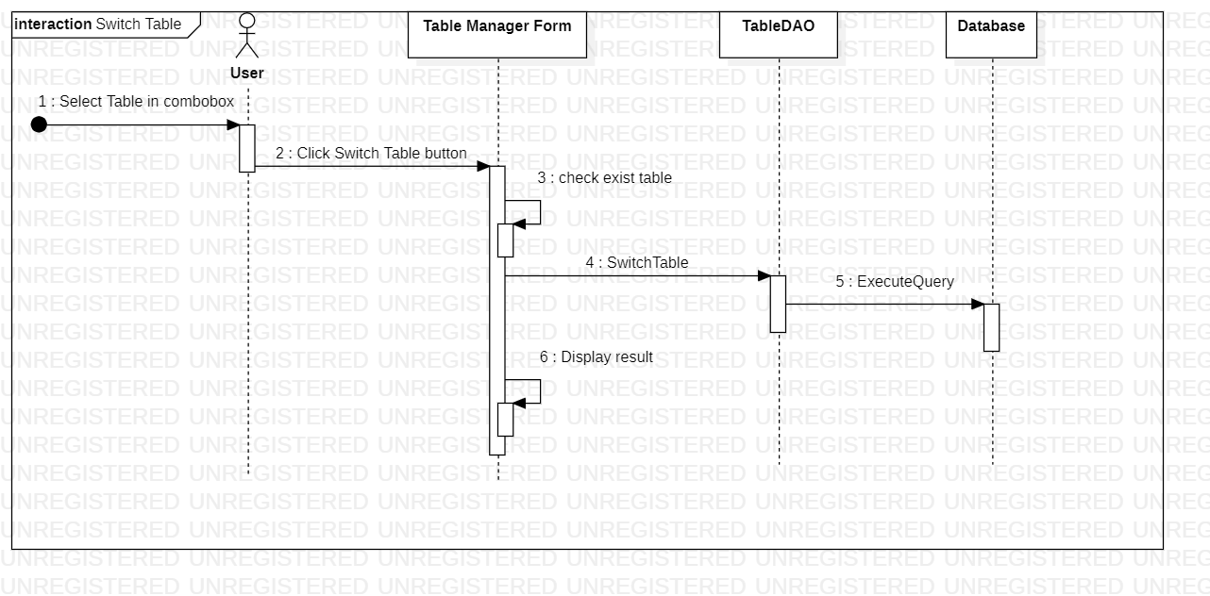Swtich Table
4. 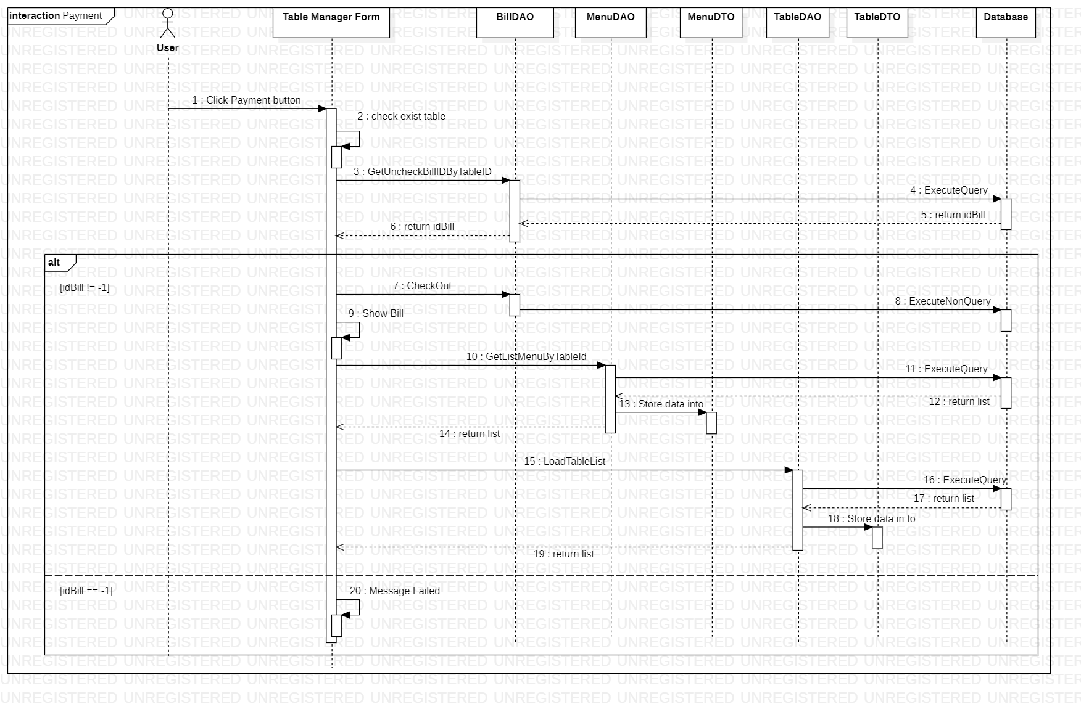Payment.
5. 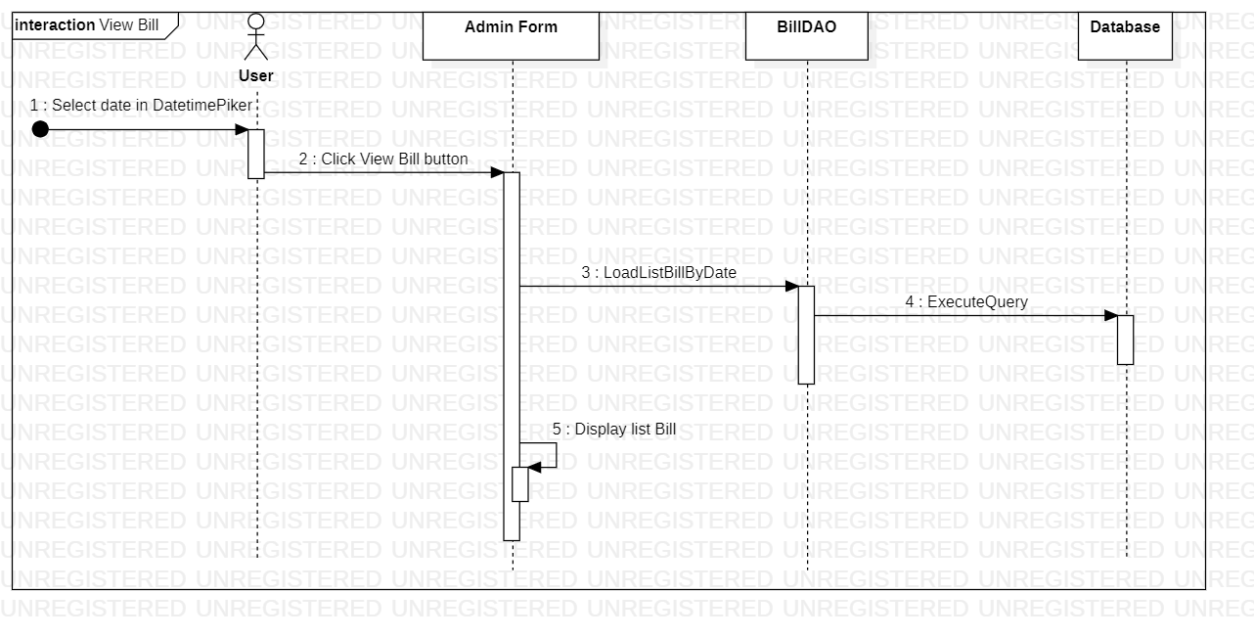View Bill.
6. 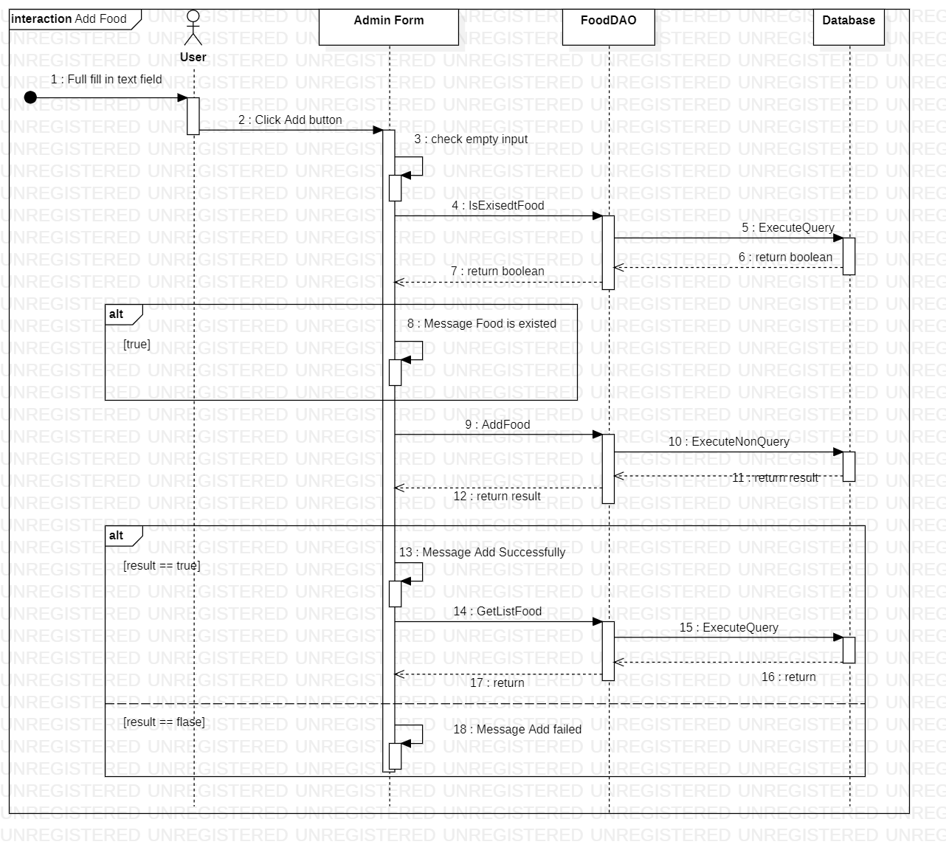Add Food
7. 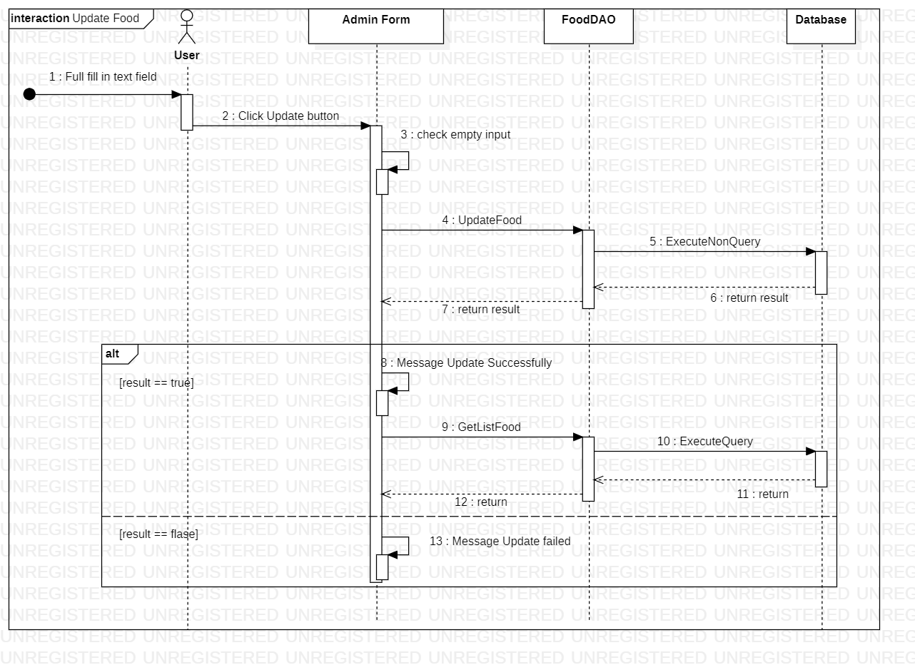Update Food
8. 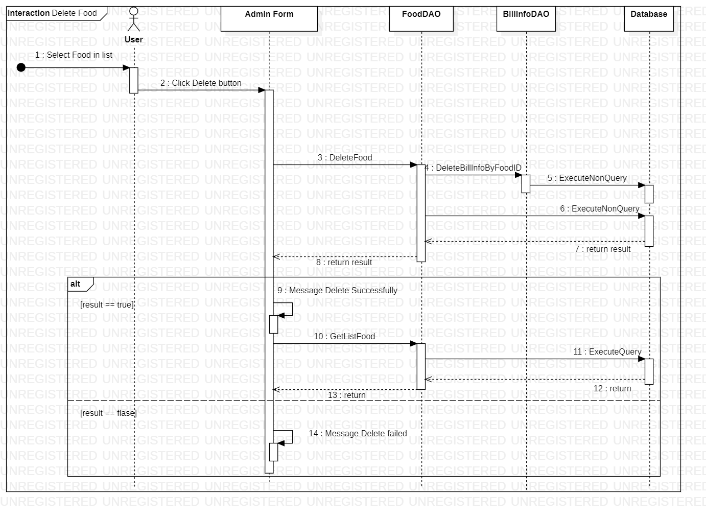Delete Food
9. 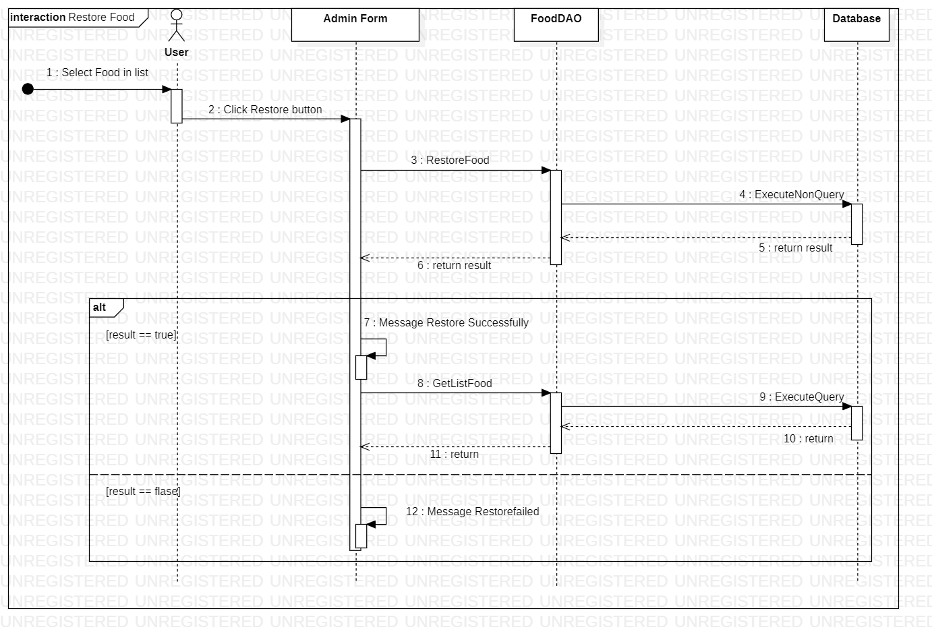Restore Food
10. 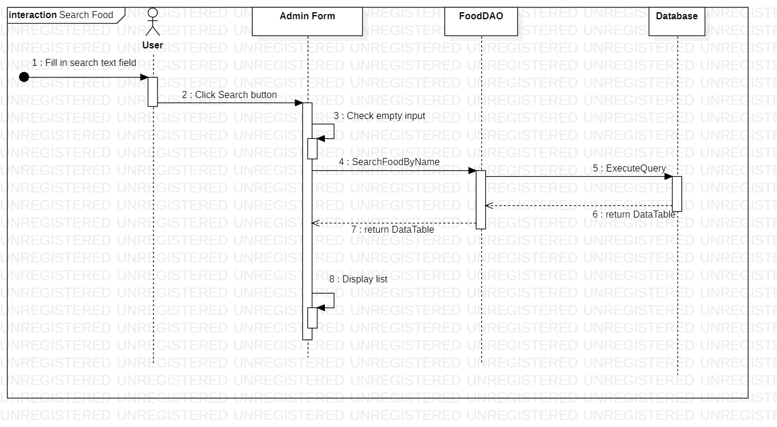Search Food
11. 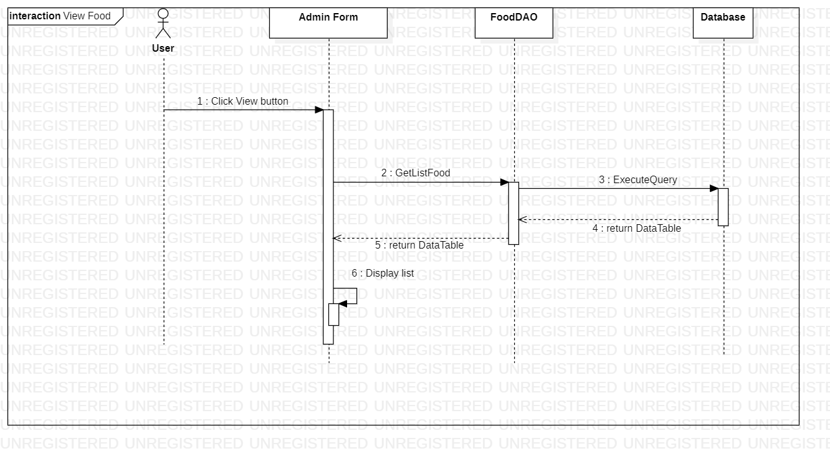View Food

1. 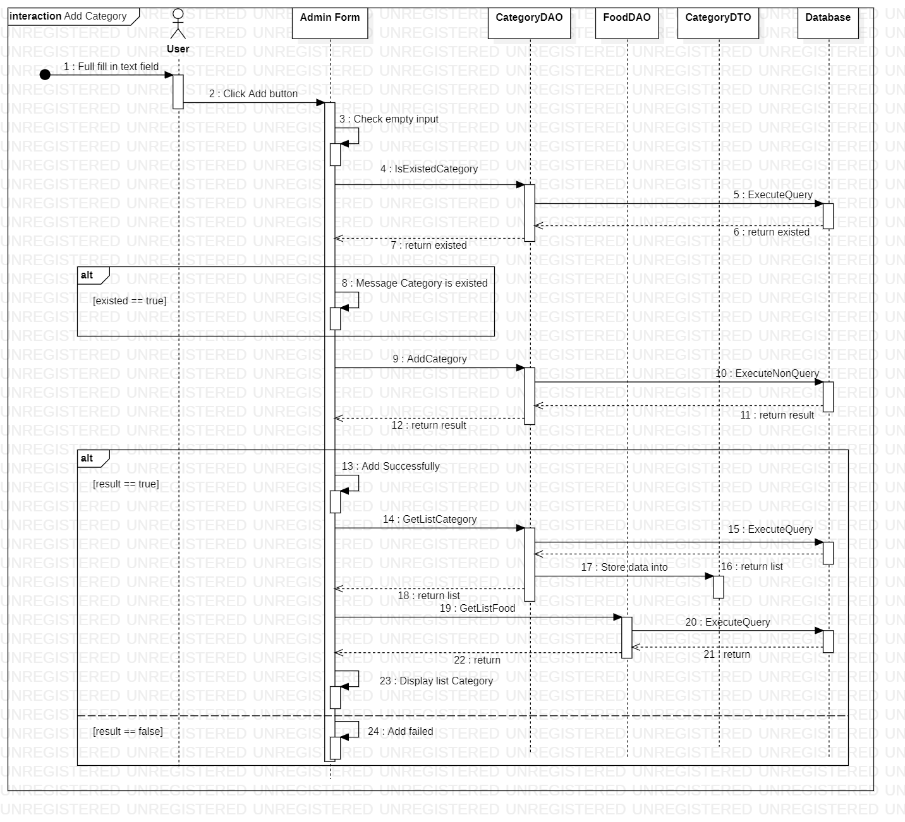Add Category
2. 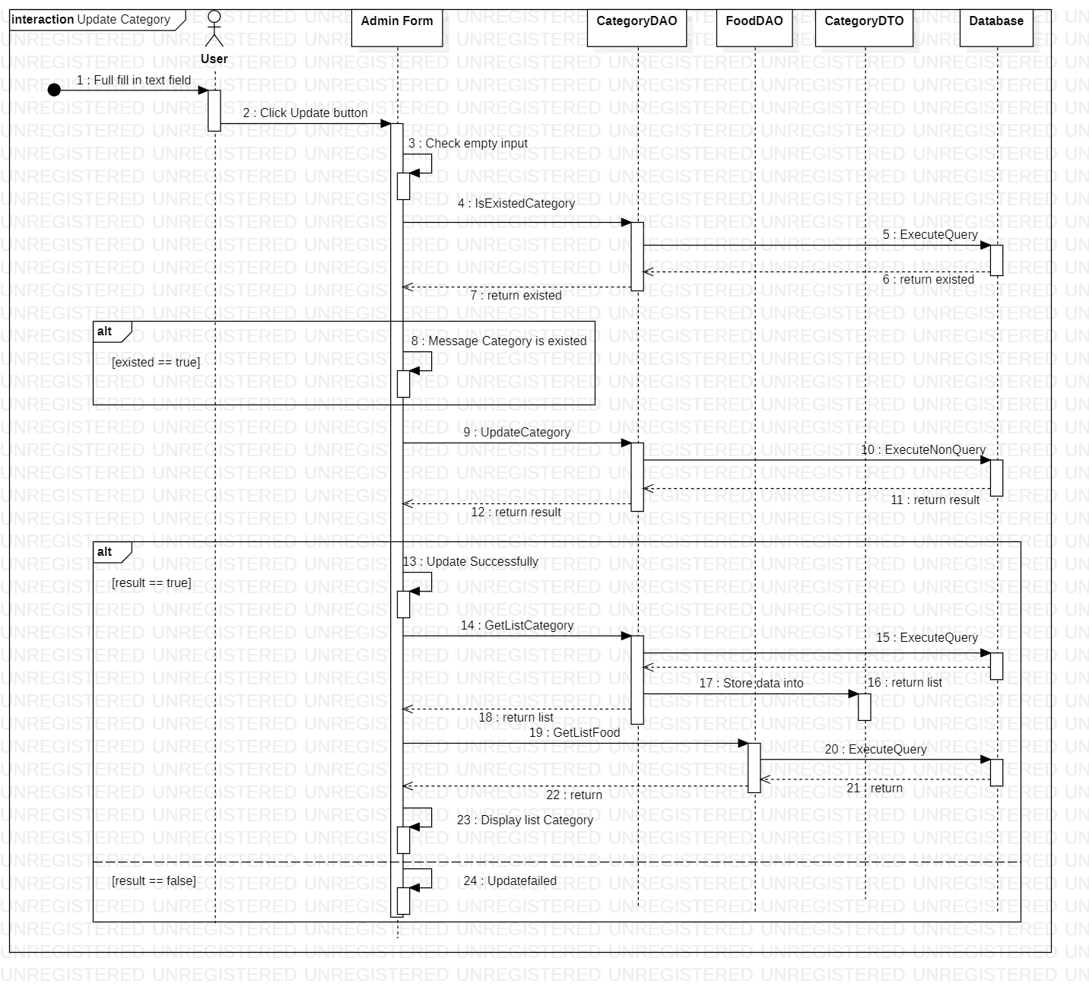Update Category
3. 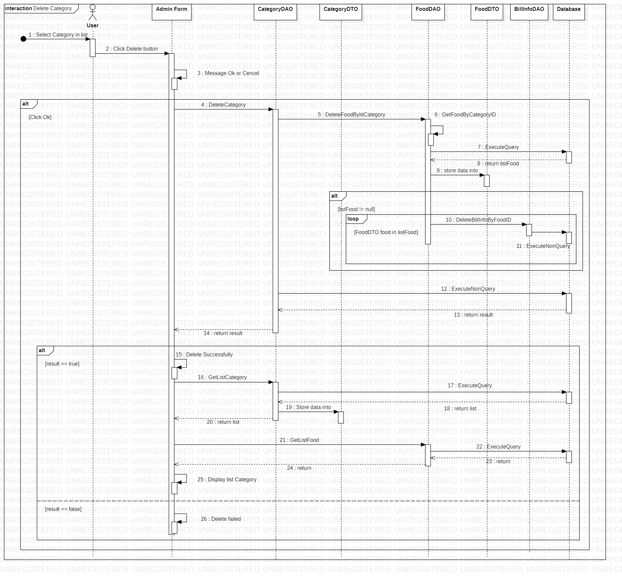Delete Category
4. View Category

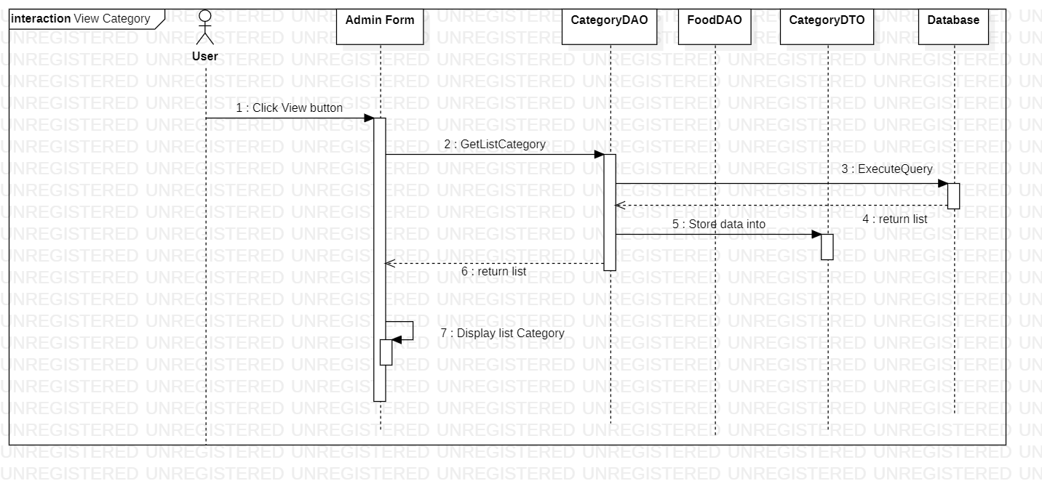

1. 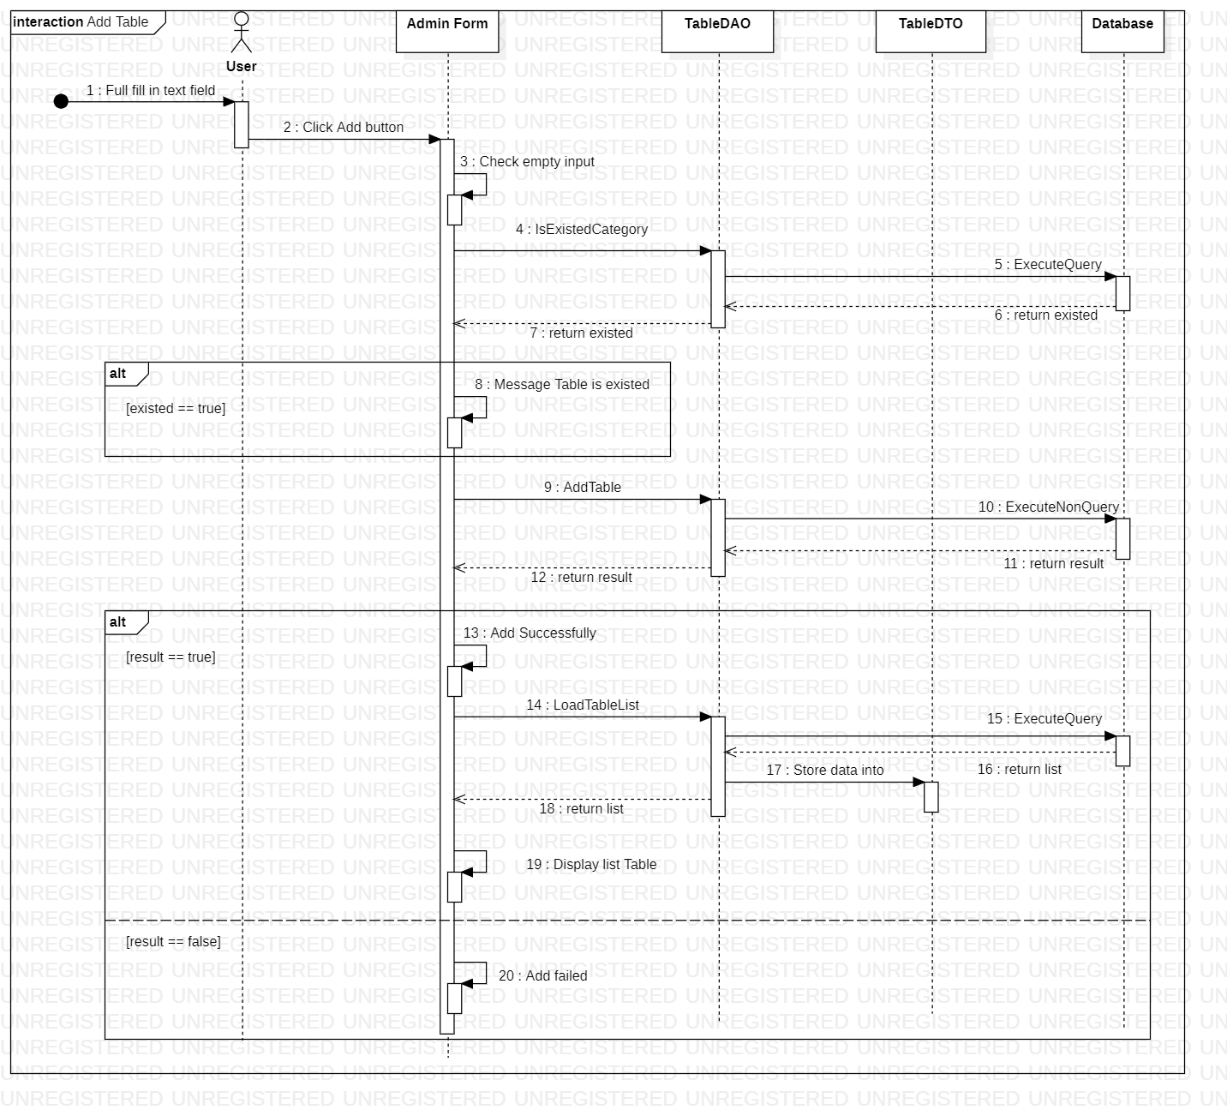Add Table
2. 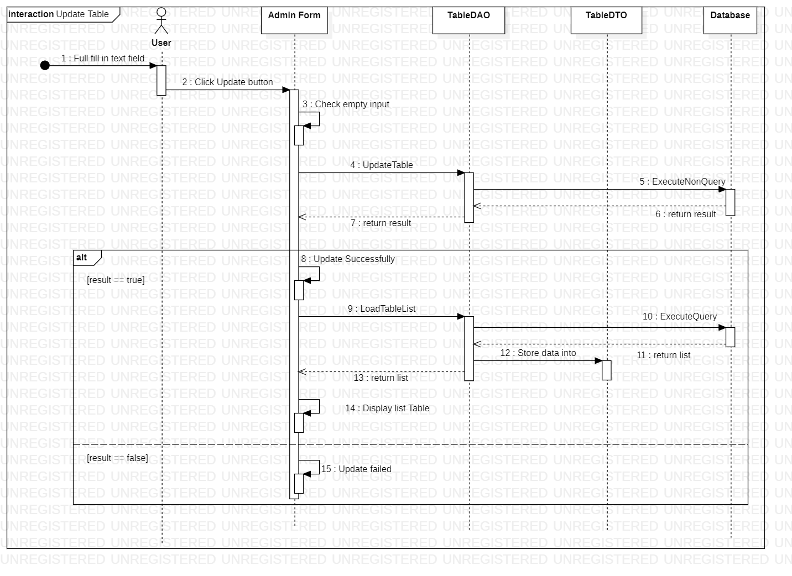Update Table
3. 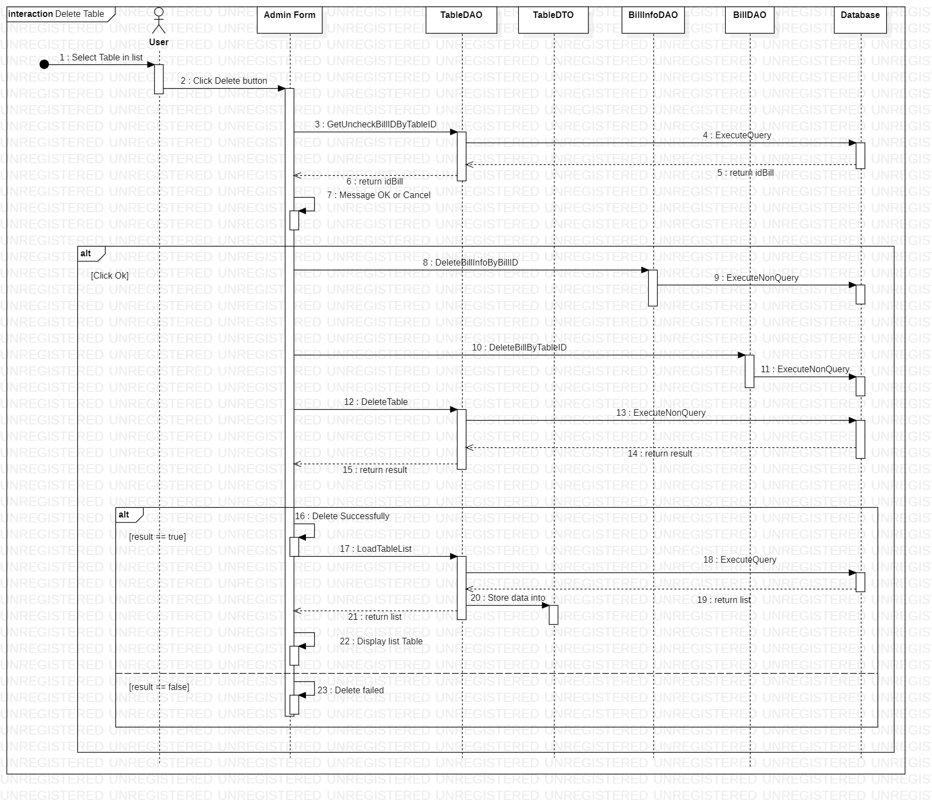Delete Table
4. 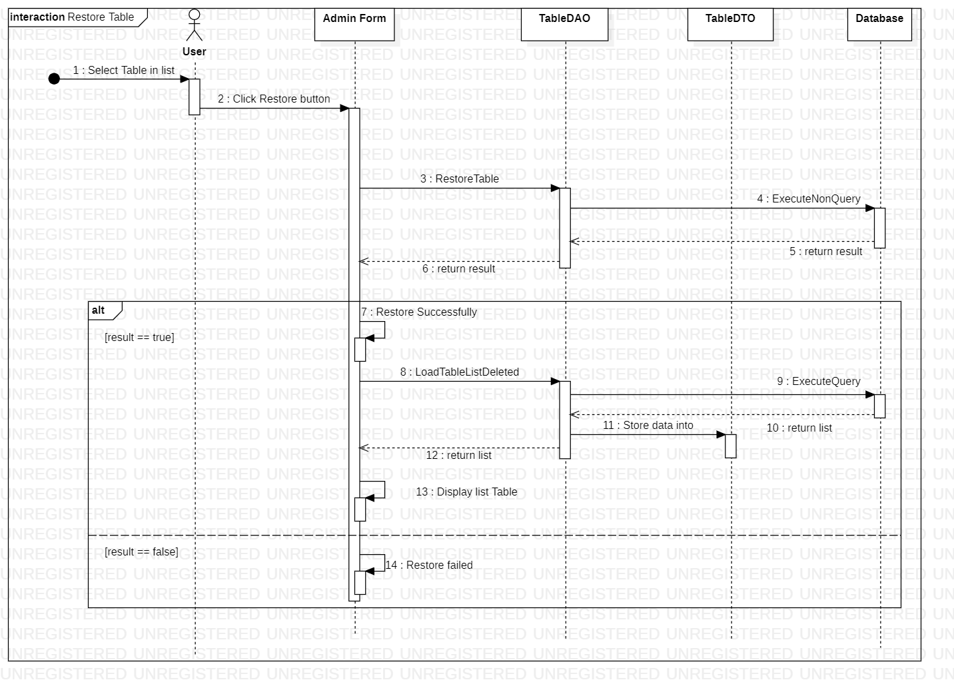Restore Table
5. 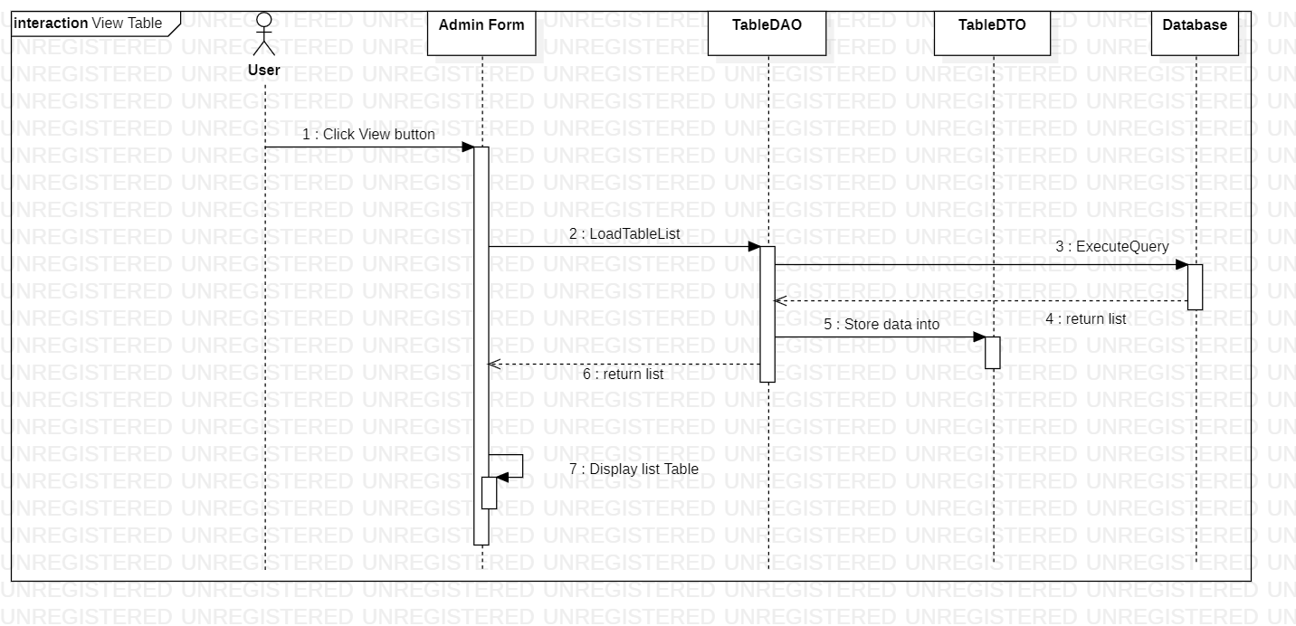View Table
6. 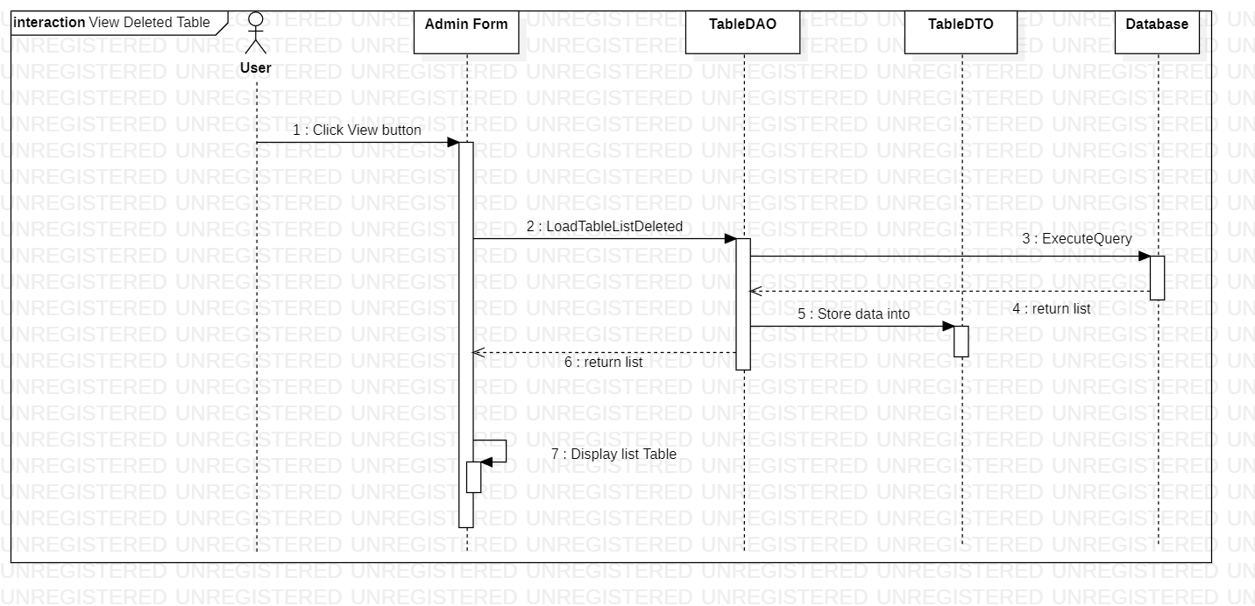View Deleted Table
7. 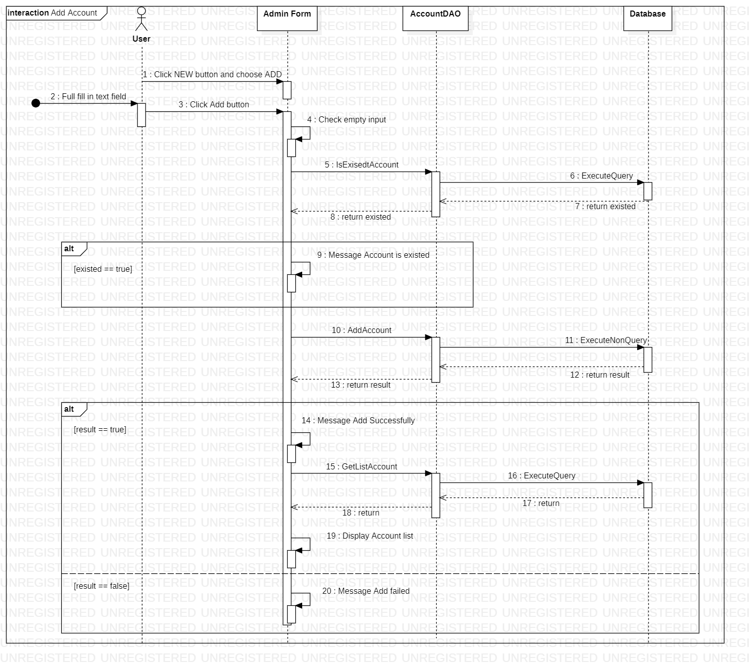Add Account
8. 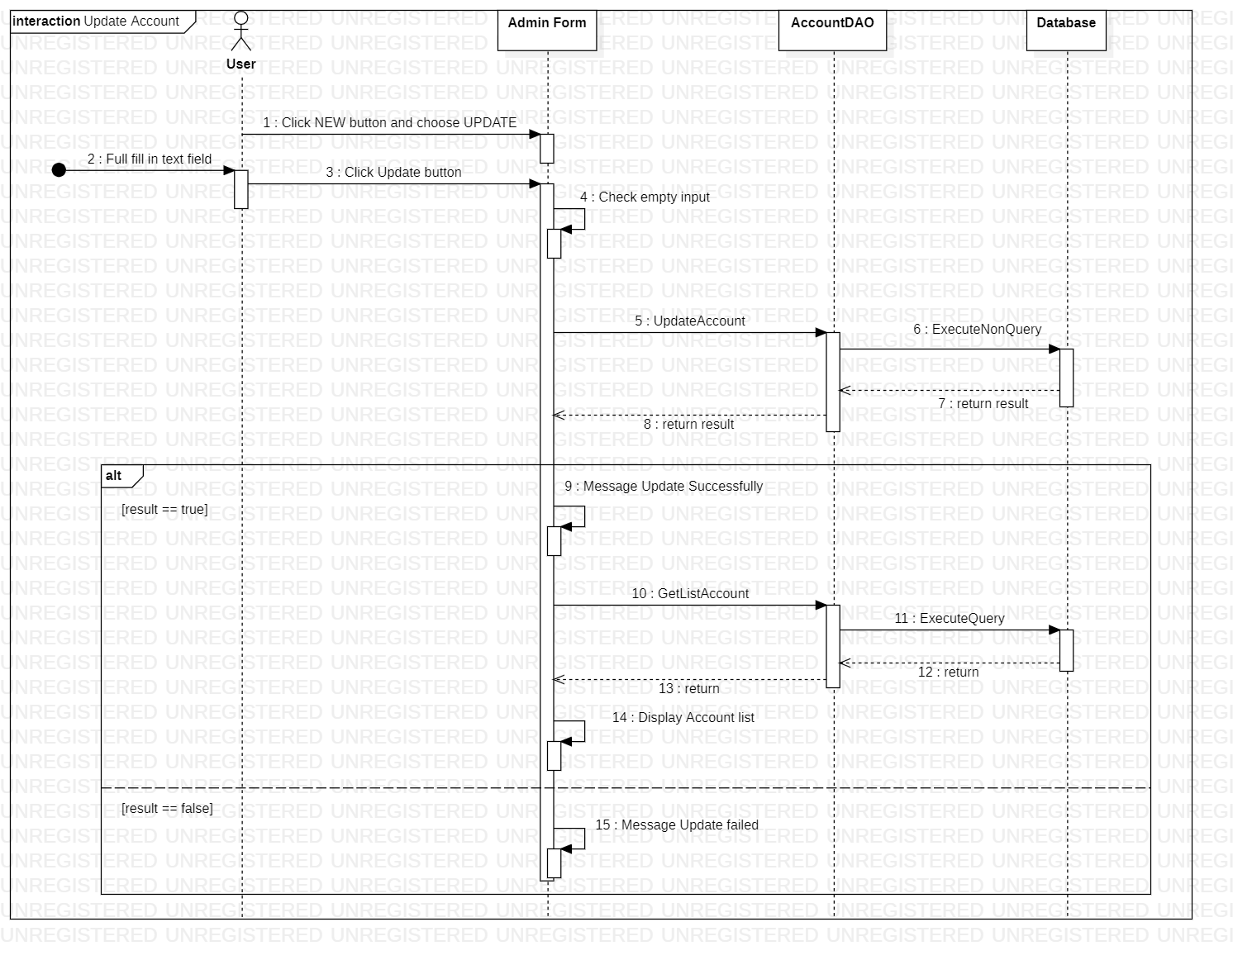Update Account
9. 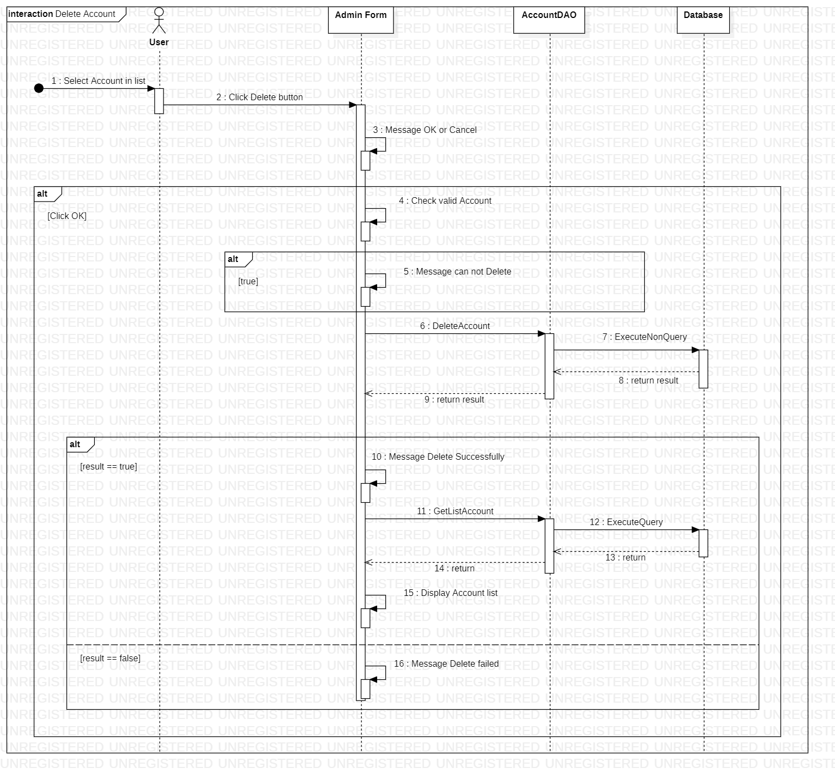Delete Account
10. 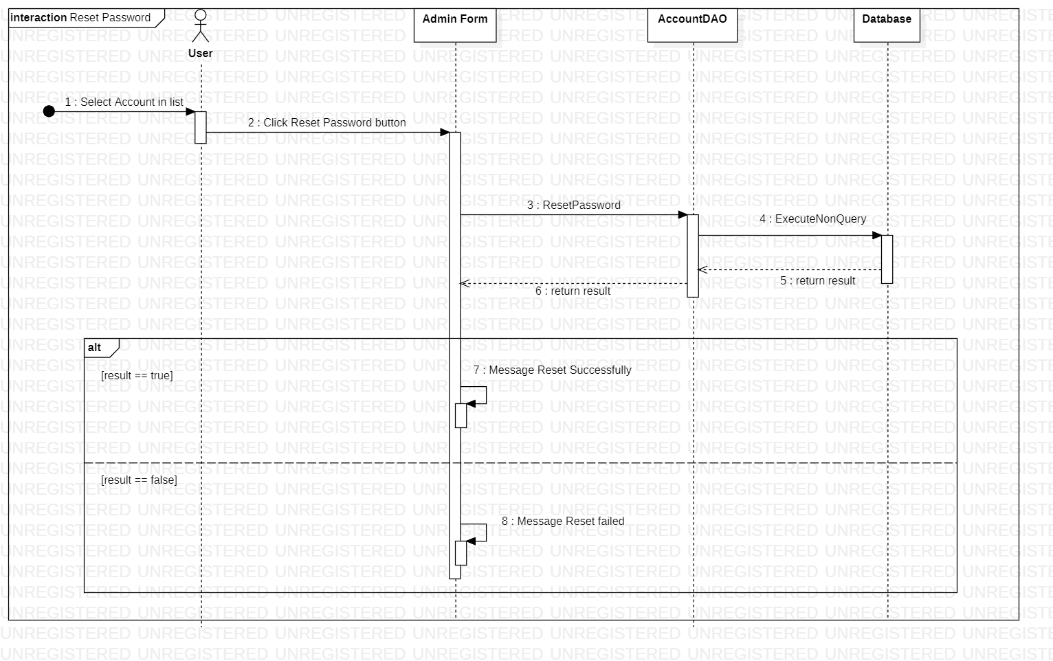Reset Password Account
11. 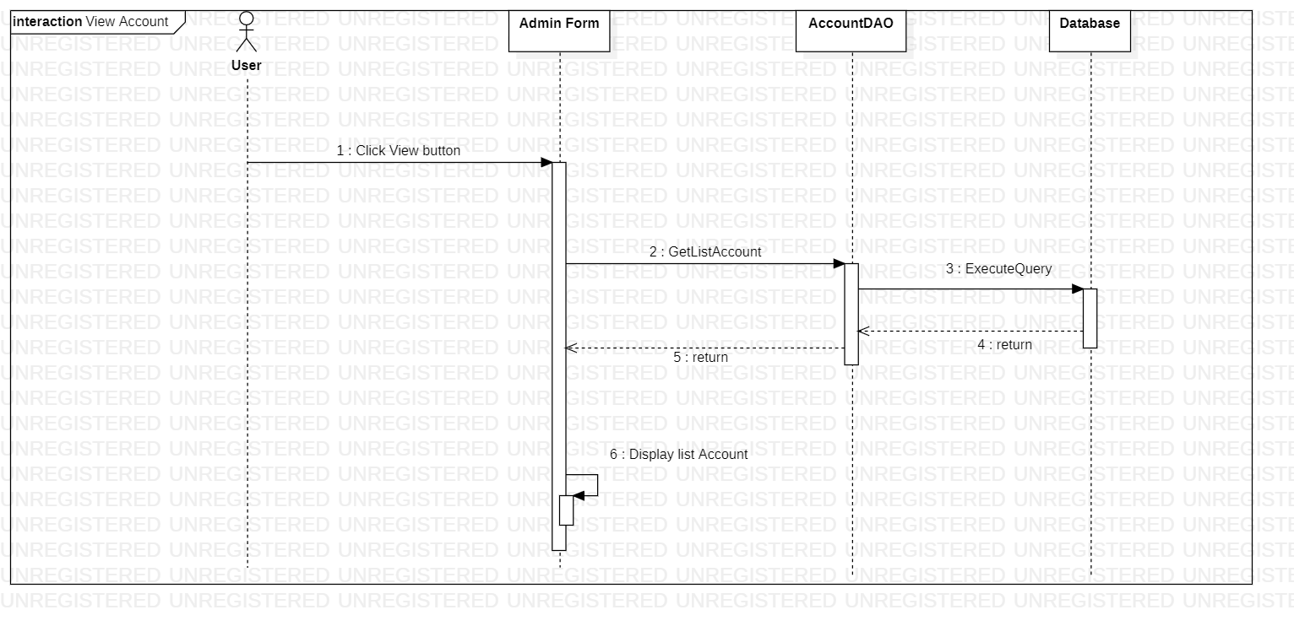View Account

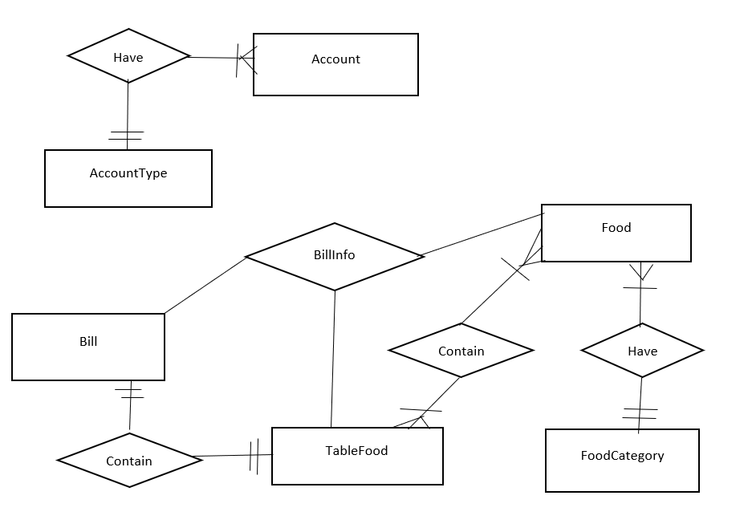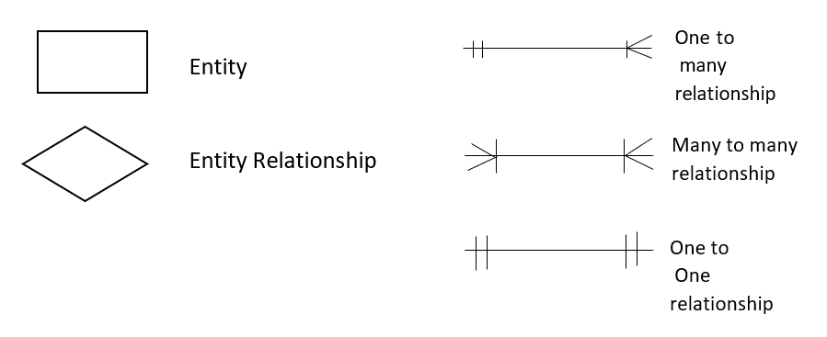ENTITY RELATIONSHIP DIAGRAM (ERD)  
Note

ENTITY DESCRIPTION

1. Account:

Account

1. AccountType:

Account

1. FoodCategory:

FoodCategory

1. Food:

FoodCategory

1. Bill

Bill

1. BillInfo:

BillInfo

1. Table Food:

TableFood

TABLE DESIGN

1. Account:

|  |  |  |  |  |  |
| --- | --- | --- | --- | --- | --- |
| **No** | **Column Name** | **Data Type** | **Size** | **Check** | **Description** |
| 1 | **🗝**UserName | Nvarchar(100) |  | Not Null | User id |
| 2 | DisplayName | Nvarchar(100) |  | Not Null | User’s Full Name |
| 3 | Password | Nvarchar(100) |  | Not Null | User’s password |
| 4 | Type | int |  | Not Null |  |

1. AccountType:

|  |  |  |  |  |  |
| --- | --- | --- | --- | --- | --- |
| **No** | **Column Name** | **Data Type** | **Size** | **Check** | **Description** |
| 1 | **🗝**TypeID | int |  | Not Null |  |
| 2 | Role | Nvarchar(100) |  | Not Null | Role of user |

1. Food:

|  |  |  |  |  |  |
| --- | --- | --- | --- | --- | --- |
| **No** | **Column Name** | **Data Type** | **Size** | **Check** | **Description** |
| 1 | **🗝**ID | int |  | Not Null | Food’s id |
| 2 | Name | Nvarchar(100) |  | Not Null | Food’s name |
| 3 | IDCategory | Int |  | Not Null |  |
| 4 | Price | float |  | Not Null | Food’s price |
| 5 | StatusFood | bit |  | Allow Null |  |

1. FoodCategory:

|  |  |  |  |  |  |
| --- | --- | --- | --- | --- | --- |
| **No** | **Column Name** | **Data Type** | **Size** | **Check** | **Description** |
| 1 | **🗝**ID | int |  | Not Null | Category’s id |
| 2 | Name | Nvarchar(100) |  | Not Null | Category’s name |

1. Bill:

|  |  |  |  |  |  |
| --- | --- | --- | --- | --- | --- |
| **No** | **Column Name** | **Data Type** | **Size** | **Check** | **Description** |
| 1 | **🗝**ID | int |  | Not Null |  |
| 2 | DateCheckIn | Date |  | Not Null |  |
| 3 | DateCheckOut | Date |  | Allow Null |  |
| 4 | IDTable | Int |  | Not Null |  |
| 5 | Status | Int |  | Not Null |  |
| 6 | Discount | Int |  | Allow Null |  |
| 7 | TotalPrice | float |  | Allow Null |  |

1. BillInfo:

|  |  |  |  |  |  |
| --- | --- | --- | --- | --- | --- |
| **No** | **Column Name** | **Data Type** | **Size** | **Check** | **Description** |
| 1 | **🗝**ID | Int |  | Not Null |  |
| 2 | IDBill | Int |  | Not Null |  |
| 3 | IDFood | Int |  | Not Null |  |
| 4 | Count | int |  | Not Null | Quantity food in bill |

1. TableFood:

|  |  |  |  |  |  |
| --- | --- | --- | --- | --- | --- |
| **No** | **Column Name** | **Data Type** | **Size** | **Check** | **Description** |
| 1 | **🗝**ID | Int |  | Not Null | ID |
| 2 | Name | Nvarchar(100) |  | Not Null | Table name |
| 3 | Status | Nvarchar(100) |  | Not Null | Empty or occupied |
| 4 | Disable | Nvarchar(100) |  | Not Null | Acctive or inactive |

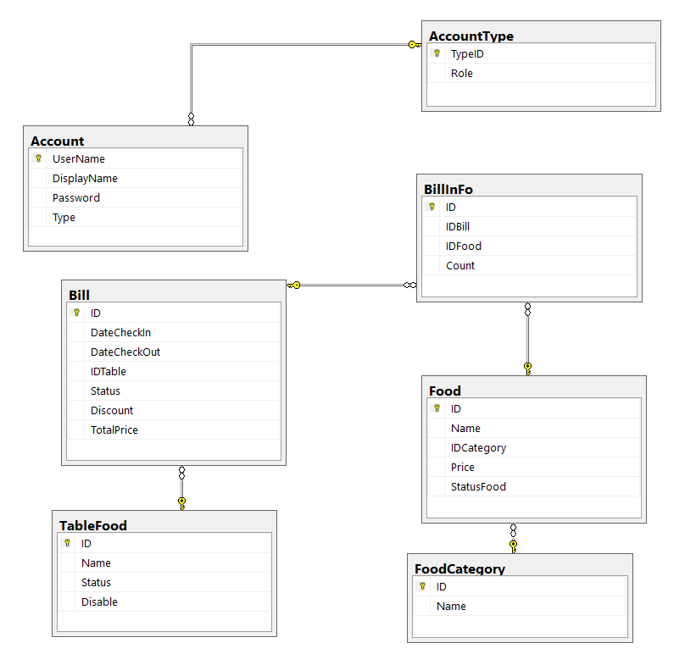TABLE RELATIONSHIP DIAGRAM

Review 3

INTERFACE DESIGN

1. Login Form:  
   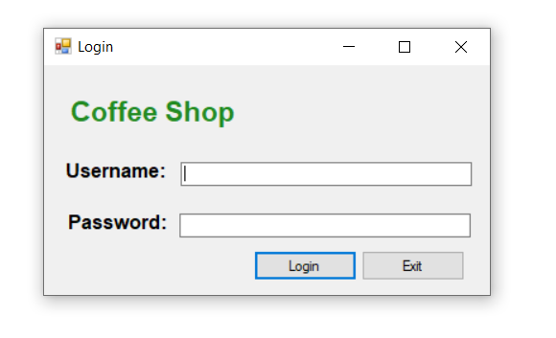

|  |  |  |  |  |  |
| --- | --- | --- | --- | --- | --- |
| **Name** | **Text** | **Type** | **Event** | **Description** | **Status** |
| label3 | Coffee Shop | Label |  |  |  |
| label1 | Username | Label |  |  |  |
| label2 | Password | Label |  |  |  |
| txtUsername |  | TextBox |  | Input username |  |
| txtPassword |  | TextBox |  | Input password |  |
| btnLogin | Login | Button | btnLogin_Click | Click to login |  |
| btnExit | Exit | Button | btnExit_Click | Click to exist app |  |
| fLogin | Login | Form | fLogin_FormClosing | Press Esc to exist |  |

1. Table Manager Form:  
   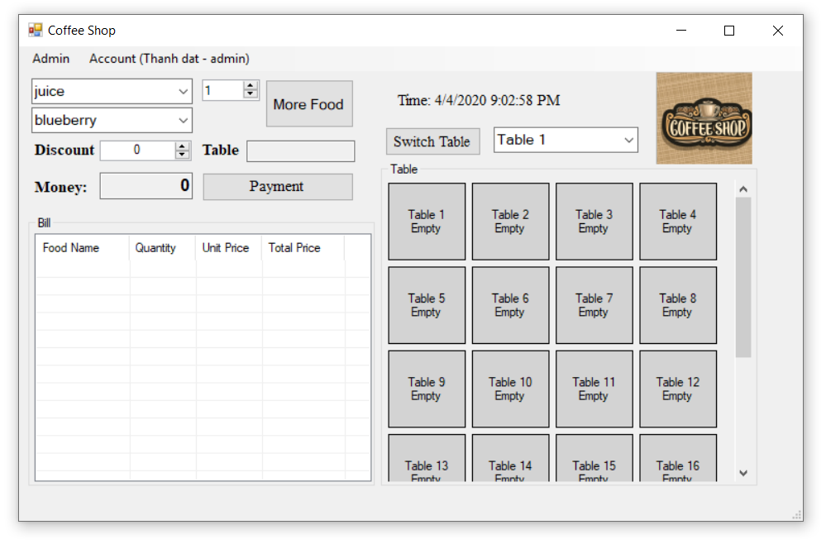

|  |  |  |  |  |  |
| --- | --- | --- | --- | --- | --- |
| **Name** | **Text** | **Type** | **Event** | **Description** | **Status** |
| adminToolStripMenuItem | Admin | menuStrip | adminToolStripMenuItem_Click |  |  |
| accountToolStripMenuItem | Account | menuStrip |  |  |  |
| personalInformationToolStripMenuItem | Personal Information | menuStrip | personalInformationToolStripMenuItem_Click |  |  |
| logoutToolStripMenuItem | Logout | menuStrip | logoutToolStripMenuItem_Click |  |  |
| label2 | Discount | Label |  |  |  |
| label1 | Money: | Label |  |  |  |
| label3 | Table | Label |  |  |  |
| lblTimer | Time: | Label |  |  |  |
| pictureBox1 |  | PictureBox |  |  |  |
| cbCategory |  | Combobox | cbCategory_SelectedIndexChanged |  |  |
| cbFood |  | Combobox |  |  |  |
| cbSwitchTable |  | Combobox |  |  |  |
| nmFoodCount | 1 | NumericUpDown |  |  |  |
| nmDiscount | 0 | NumericUpDown |  |  |  |
| flpTable |  | FlowLayoutPanel |  |  |  |
| lsvBill |  | ListView |  |  |  |
| btnMoreFood | More Food | Button | btnMoreFood_Click |  |  |
| btnPay | Payment | Button | btnPay_Click |  |  |
| btnChangeTable | Switch Table | Button | btnChangeTable_Click |  |  |
| txtTable |  |  |  |  | Read Only |
| txtMoney | 0 |  |  |  | Read Only |
| timer |  | Timer | timer_Tick |  |  |

1. Profile Form:

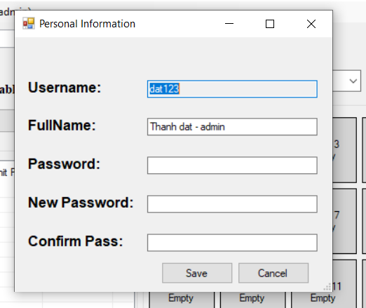

|  |  |  |  |  |  |
| --- | --- | --- | --- | --- | --- |
| **Name** | **Text** | **Type** | **Event** | **Description** | **Status** |
| lblMessage | message | Label |  |  |  |
| label1 | Username: | Label |  |  |  |
| label2 | FullName: | Label |  |  |  |
| label3 | Password: | Label |  |  |  |
| label4 | New Password: | Label |  |  |  |
| label5 | Confirm Pass: | Label |  |  |  |
| txtUsername |  | TextBox |  |  | ReadOnly |
| txtDisplayName |  | TextBox |  |  |  |
| txtPassword |  | TextBox |  |  |  |
| txtNewPassword |  | TextBox |  |  |  |
| txtConfirmPass |  | TextBox |  |  |  |
| btnSave | Save | Button | btnSave_Click |  |  |
| btnCancel | Cancel | Button | btnCancel_Click |  |  |

1. 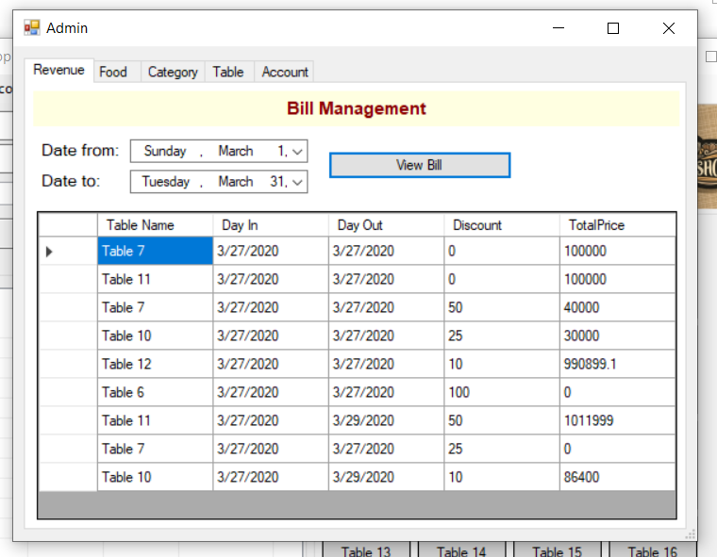Admin From (Revenue):

|  |  |  |  |  |  |
| --- | --- | --- | --- | --- | --- |
| **Name** | **Text** | **Type** | **Event** | **Description** | **Status** |
| label15 | Bill Management | Label |  |  |  |
| label10 | Date from: | Label |  |  |  |
| label14 | Date to: | Label |  |  |  |
| dtpkFormDate |  | DateTimePicker |  |  |  |
| dtpkToDate |  | DateTimePicker |  |  |  |
| btnViewBill | View Bill | Button | btnViewBill_Click |  |  |
| dgvBill |  | DataGridView |  |  |  |

1. Admin From (Food):  
     
   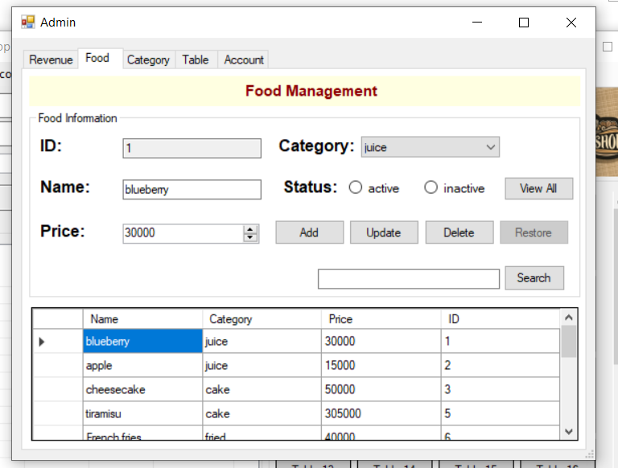

|  |  |  |  |  |  |
| --- | --- | --- | --- | --- | --- |
| **Name** | **Text** | **Type** | **Event** | **Description** | **Status** |
| label16 | Food Management | Label |  |  |  |
| label1 | ID: | Label |  |  |  |
| label2 | Name: | Label |  |  |  |
| label4 | Price: | Label |  |  |  |
| label3 | Category: | Label |  |  |  |
| label20 | Status: | Label |  |  |  |
| txtFoodID |  | TextBox |  |  | ReadOnly |
| txtFoodName |  | TextBox |  |  |  |
| txtSearchFood |  | TextBox |  |  |  |
| cbFoodCategory |  | ComBoBox |  |  |  |
| nmFoodPrice | 0 | NumericUoDown |  |  |  |
| rdActive | active | RadioButton | rdActive_CheckedChanged |  |  |
| rdInactive | inactive | RadioButton | rdInactive_CheckedChanged |  |  |
| btnAddFood | Add | Button | btnAddFood_Click |  |  |
| btnUpdateFood | Update | Button | btnUpdateFood_Click |  |  |
| btnDeleteFood | Delete | Button | btnDeleteFood_Click |  |  |
| btnRestore | Restore | Button | btnRestore_Click |  |  |
| btnViewFood | View All | Button | btnViewFood_Click |  |  |
| btnSearchFood | Search | Button | btnSearchFood_Click |  |  |
| dgvFood |  | DataGridView |  |  |  |

1. Admin From (Category):  
   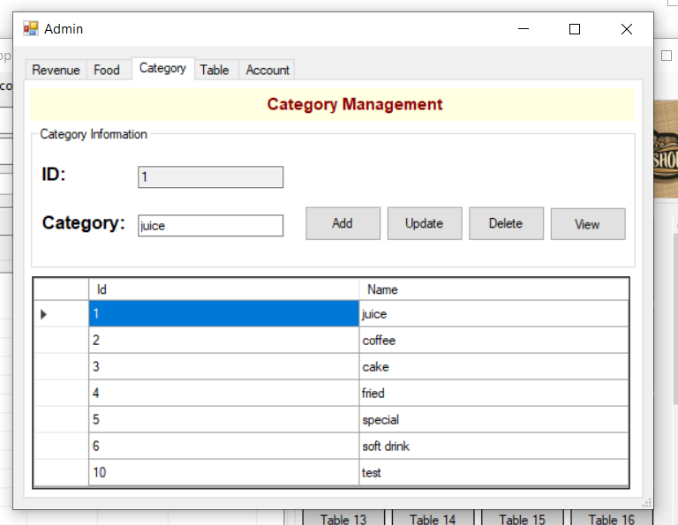

|  |  |  |  |  |  |
| --- | --- | --- | --- | --- | --- |
| **Name** | **Text** | **Type** | **Event** | **Description** | **Status** |
| label17 | Category Management | Label |  |  |  |
| label8 | ID: | Label |  |  |  |
| label7 | Category: | Label |  |  |  |
| txtCategoryID |  | TextBox |  |  | ReadOnly |
| txtCateName |  | TextBox |  |  |  |
| btnAddCate |  | Button | btnAddCate_Click |  |  |
| btnUpdateCate |  | Button | btnUpdateCate_Click |  |  |
| btnDeleteCate |  | Button | btnDeleteCate_Click |  |  |
| btnViewCate |  | Button | btnViewCate_Click |  |  |
| dgvCategory |  | DataGridView |  |  |  |

1. Admin From (Table):  
     
   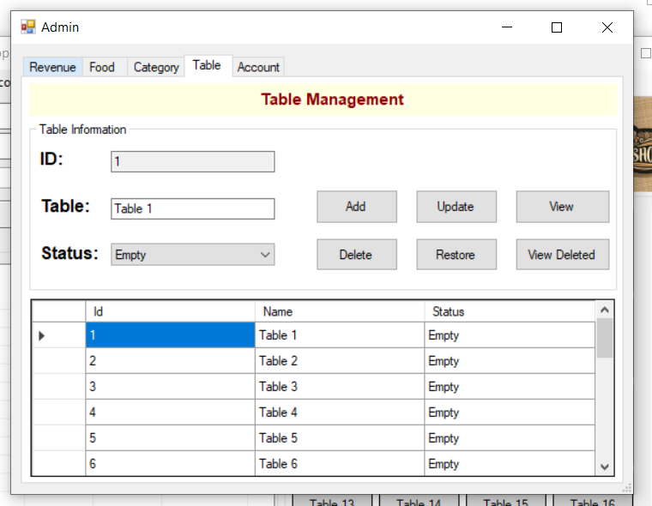

|  |  |  |  |  |  |
| --- | --- | --- | --- | --- | --- |
| **Name** | **Text** | **Type** | **Event** | **Description** | **Status** |
| label18 | Table Management | Label |  |  |  |
| label6 | ID: | Label |  |  |  |
| label5 | Table: | Label |  |  |  |
| label9 | Status: | Label |  |  |  |
| txtTableID |  | TextBox |  |  | ReadOnly |
| txtTableName |  | TextBox |  |  |  |
| cbTableStatus |  | ComBoBox |  |  | ReadOnly |
| btnAddTable | Add | Button | btnAddTable_Click |  |  |
| btnUpdateTable | Update | Button | btnUpdateTable_Click |  |  |
| btnDeleteTable | Delete | Button | btnDeleteTable_Click |  |  |
| btnRestoreTable | Restore | Button | btnRestoreTable_Click |  |  |
| btnViewTable | View | Button | btnViewTable_Click |  |  |
| btnViewDeleted | View Deleted | Button | btnViewDeleted_Click |  |  |
| dgvTable |  | DataGridView |  |  |  |

1. Admin From (Account):  
     
   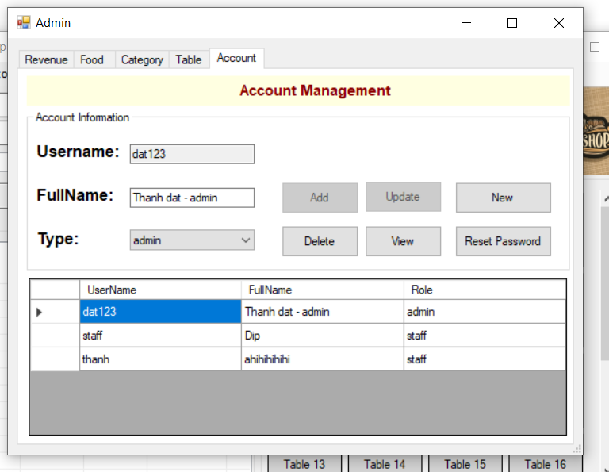

|  |  |  |  |  |  |
| --- | --- | --- | --- | --- | --- |
| **Name** | **Text** | **Type** | **Event** | **Description** | **Status** |
| label19 | Account Management | Label |  |  |  |
| label13 | Username: | Label |  |  |  |
| label12 | FullName: | Label |  |  |  |
| label11 | Type: | Label |  |  |  |
| txtUsername |  | TextBox |  |  | ReadOnly |
| txtFullName |  | TextBox |  |  |  |
| cbAccountType |  | ComBoBox |  |  | ReadOnly |
| btnAddAccount | Add | Button | btnAddAccount_Click |  |  |
| btnUpdateAccount | Update | Button | btnUpdateAccount_Click |  |  |
| btnDeleteAccount | Delete | Button | btnDeleteAccount_Click |  |  |
| btnNew | New | Button | btnNew_Click |  |  |
| btnViewAccount | View | Button | btnViewAccount_Click |  |  |
| btnResetPass | Reset Password | Button | btnResetPass_Click |  |  |
| dgvAccount |  | DataGridView |  |  |  |